Morning Glory

EUR 8,250,000

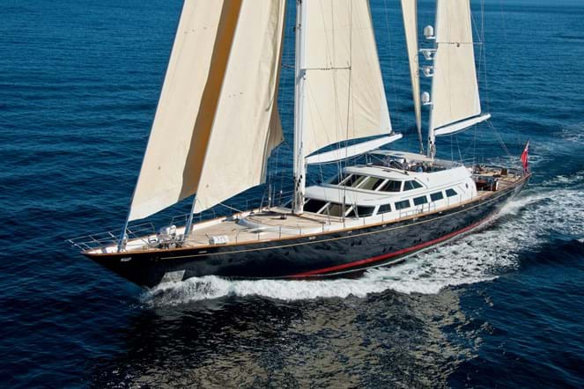

## Asking price: **EUR 8,250,000**

## Built: **1994 (refitted 2019), Naval Perini, Italy**

## Length: **43.9m (144ft)**

## Guests: **8 in 4 cabins**

# Description:

### The 48.2m (158.1ft) MORNING GLORY is a ketch-rigged sailing yacht delivered in 1993. The second of the celebrated 48m series to be built at the Viareggio shipyard, her steel hull and aluminium superstructure were constructed to ABS classification and designed inside and out by the yard's renowned in-house team.

MORNING GLORY was extensively rebuilt in 2010 including new engines and generators and was refitted again in 2016/2017 including a full repaint amongst many other works. Benefitting from a thorough maintenance schedule, MORNING GLORY is a first-class yacht from the world-renowned Perini Navi shipyard.

As a motor yacht that sails, she offers both the comfort and convenience of the former and the efficiency and exhilaration of the latter. She has generous and versatile deck spaces. Her flybridge has a bimini awning covering the helm station and there is an L-shaped lounge to port and a sofa to starboard, all with panoramic views of the cruising ground from beneath a cloud of sail above. A spiral staircase around the mizzen mast leads down to the main deck.

Immediately aft of the main saloon is a dining area partially shaded by the aft flybridge. Steps lead up to side decks port and starboard leading to the expansive foredeck where the tenders are stored on passage. Aft of the dining table is a semi-circle of seating around an oval table and steps lead up either side to a raised sun lounge.

Her interior showcases the many talents of Perini Navi with warm woods beautifully crafted throughout. The spacious main saloon features U-shaped seating facing a working marble fireplace forward. A passage to starboard leads to the forward saloon with a formal dining area to port and a fully equipped sit-up bar and games table to starboard.

MORNING GLORY can accommodate eight guests in four luxurious suites. A full beam owner's suite on the lower deck aft has a master study along with separate his and her bathrooms. Two double cabins and two twin cabins complete the guest accommodation and she also sleep up to eight crew.

She has 990sqm (10,645sqft) of easily handled sail area delivering comfort and performance, improved by her centreboard, which gives her a maximum draft of 7.7m (25.7ft) when down, reducing to 3.3m (10.8ft) to allow access to off the beaten path lagoons and ports. When not sailing, twin 850hp MAN diesel engines give her a top speed of 14.5 knots and a trans-oceanic range of 4,900nm at 10 knots.

# Key features:

* *Classic Perini ketch with timeless lines and elegant interiors*
* *Substantially rebuilt and upgraded throughout her ownerships*
* *25 year ABS survey completed in 2017 including flybridge extension, full rig refit and hull & superstructure repaint.*